Leadership in the Workplace: 10 Skills To Develop (With FAQ)

**Indeed Editorial Team**

Updated November 28, 2023

**Video: How to Lead by Example**

*Leading by example is one of the most powerful forms of leadership! In this video, we break down how you can become an example leader, why it's important, and more!*

Leadership skills can help you in all phases of your career, from applying to jobs to seeking career advancement. As one of the key soft skills employers value, leadership often incorporates several other personality traits

and communication abilities that anyone can learn and practice. Understanding leadership skills and how to develop them can be beneficial to your career.

In this article, we discuss 10 top leadership skills and their components, as well as offer tips for developing your skills as a leader and highlighting them on your resume.

**Related:** [**Leadership Philosophy: What It is and How To Create One**](https://www.indeed.com/career-advice/career-development/leadership-philosophy)



What are your desired job types? *

Full-time

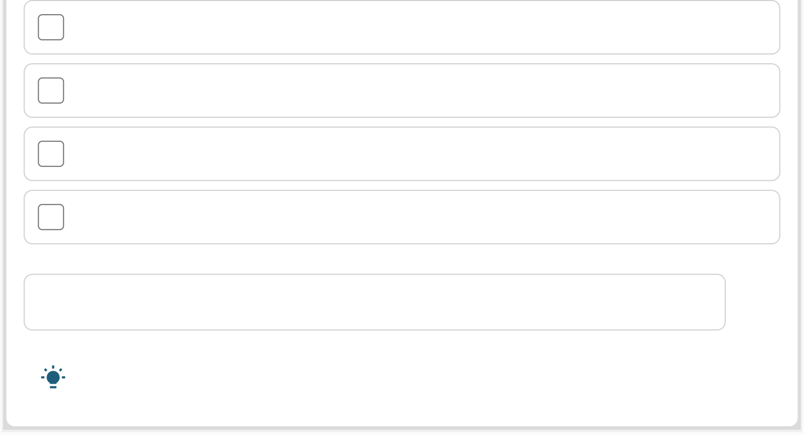

Part-time

Contract

Temporary

Internship

**Save**

We'll use this to improve your job recommendations.

# What are leadership skills?

Leadership skills help encourage and organize others to reach a shared goal. Whether you're a manager, a project leader or a team member, these skills allow you to motivate others. Leadership is not just one skill but a combination of

several different skills.

If you're applying for jobs that require you to take the initiative and be a leader— whether as a manager or among your fellow peers—you should list leadership skills on your resume. If you aren't sure how to highlight your leadership skills on a resume, you can get professional, customized help with our [**resume feedback**](https://resume-review.indeed.com/?collectorID=paLeadershipSkills)[**questionnaire**](https://resume-review.indeed.com/?collectorID=paLeadershipSkills)

.

[**Download Resume Template**](https://assets.ctfassets.net/pdf29us7flmy/1Smlk4qjIKRrgzSHskb0T7/6d3df2e59a6cea00791618cf83de0372/Resume_Template.docx)

*To upload the template into Google Docs, go to File > Open > and select the correct downloaded file.*

**Related:** [**Commitment in Leadership: Why It's Important**](https://www.indeed.com/career-advice/career-development/commitment-leadership)

[**See your instant resume report on Indeed**](https://www.indeed.com/career-services/resume-help/instant-report?collectorID=careerguidepromo-US&from=careerguidepromo-US)

Get recommendations for your resume in minutes

# 10 key leadership skills

Here's a list of valuable leadership skills for anyone applying for work or looking to advance in their career:

## Decisiveness

Decisiveness is a valuable leadership skill that can help to move projects along faster and improve efficiency. Strong [decision-making](https://www.indeed.com/career-advice/career-development/decision-making-skills)

skills aid in your ability to choose solutions to challenges. Effective decisiveness requires research, evaluation, problem-solving and goal-setting, often with a quick turnaround. Key skills related to being a strong, decisive leader include:

[Problem-solving](https://www.indeed.com/career-advice/resumes-cover-letters/problem-solving-skills)

[Initiative](https://www.indeed.com/career-advice/career-development/ways-to-take-initiative-at-work)

[Research](https://www.indeed.com/career-advice/career-development/research-skills)

[Project evaluation](https://www.indeed.com/career-advice/career-development/project-evaluation)

[Expectation setting](https://www.indeed.com/career-advice/career-development/how-to-manage-expectations-at-work)

**Note:** Decision-making skills help you make informed decisions once you've collected all the relevant information and considered the multiple viewpoints.

**Related:** [**11 Steps To Become More Decisive at Work**](https://www.indeed.com/career-advice/career-development/how-to-be-more-decisive-at-work)

## Integrity

[Integrity](https://www.indeed.com/career-advice/career-development/integrity-at-work)

is often seen as simply truthfulness or honesty. However, it also means having— and standing by—a [set of strong values](https://www.indeed.com/career-advice/career-development/leader-values)

. It's behaving honorably, even when no one is watching. Integrity in the workplace often means making ethical choices and helping the company maintain a positive image. All businesses seek to hire workers who have a strong sense of integrity. A leader with integrity also shows the following skills:

[Diplomacy](https://www.indeed.com/career-advice/resumes-cover-letters/diplomatic-skills)

[Ethics](https://www.indeed.com/career-advice/career-development/ethical-leadership)

[Reliability](https://www.indeed.com/career-advice/career-development/work-ethic-skills)

[Professionalism](https://www.indeed.com/career-advice/career-development/the-ultimate-guide-to-professionalism)

[Responsibility](https://www.indeed.com/career-advice/career-development/difference-accountability-responsibility)

[Confidentiality](https://www.indeed.com/career-advice/interviewing/how-do-you-handle-confidential-information)

[Honesty](https://www.indeed.com/career-advice/career-development/integrity-at-work-examples)

**Note:** Having integrity as a leader encourages the most truthful and fair outcome and sets a positive example for your team.

**Read more:** [**Integrity in the Workplace: Definition and Examples**](https://www.indeed.com/career-advice/career-development/integrity-at-work)

## Creativity

Good leaders often have to make decisions that don't have a clear answer, requiring them to think outside the box. Leaders with creativity promote a free exchange of new ideas. They inspire innovation and collaboration in the workplace. A leader with creativity also shows the following skills:

[Critical thinking](https://www.indeed.com/career-advice/career-development/critical-thinking-skills)

[Curiosity](https://www.indeed.com/career-advice/career-development/what-is-intellectual-curiosity)

[Diversity](https://www.indeed.com/career-advice/career-development/types-of-diversity-in-workplace)

[Innovation](https://www.indeed.com/career-advice/career-development/innovation-skills)

[Collaboration](https://www.indeed.com/career-advice/career-development/collaboration-skills)

[Open-mindedness](https://www.indeed.com/career-advice/career-development/open-minded)

**Note:** While creative thinking is more of a quality than a skill, it can still developed over time.

**Read more:** [**8 Ways to Use Creativity in Leadership**](https://www.indeed.com/career-advice/career-development/creativity-in-leadership)

## Flexibility

A good leader should be flexible, accepting last-minute changes or new issues. You should also be open to suggestions and feedback. Managing the unexpected, initiating new courses of action and proposing new solutions can positively impact your team. Flexible leaders display skills such as:

[Negotiation](https://www.indeed.com/career-advice/career-development/negotiation-skills)

[Adaptability](https://www.indeed.com/career-advice/career-development/adaptability-skills)

[Strength](https://www.indeed.com/career-advice/starting-new-job/strengths-at-workplace)

and [weakness](https://www.indeed.com/career-advice/career-development/how-to-overcome-your-weakness)

recognition

[Feedback](https://www.indeed.com/career-advice/career-development/principles-of-feedback)

[Work-life balance](https://www.indeed.com/career-advice/career-development/work-life-balance)

**Note:** Flexibility in business can make employees feel more valued whil building trust and fostering a more creative working environment.

**Read more:** [**11 Ways To Improve Your Flexibility in Leadership**](https://www.indeed.com/career-advice/career-development/flexibility-in-leadership)

## Positive attitude

An effective leader knows that a positive attitude can go a long way in the workplace. You work to create a positive work environment—even during stressful periods. Employees are more likely to be productive and motivated to do their best when they're happy and feel they're valued. Skills that help promote a good work environment include:

[Conflict management](https://www.indeed.com/career-advice/career-development/conflict-management-skills)

[Social skills](https://www.indeed.com/career-advice/career-development/social-skills)

[Rapport](https://www.indeed.com/career-advice/starting-new-job/building-rapport)

[Empathy](https://www.indeed.com/career-advice/career-development/empathic-skills)

[Positive reinforcement](https://www.indeed.com/career-advice/career-development/positive-working-environment)

[Respect](https://www.indeed.com/career-advice/career-development/workplace-respect)

**Note:** Asking questions about outside interests, vacations, etc., can hel promote a positive workplace and good morale.

**Read more:** [**Positive Leadership: 32 Traits of Positive Leaders**](https://www.indeed.com/career-advice/career-development/positive-leadership)

## Communication

Good leaders can clearly explain things to their team, from organizational goals to specific tasks. Open communication between executives, managers and team members promotes a comfortable atmosphere and transparency. A good leader needs a variety of communication skills, including:

[Active listening](https://www.indeed.com/career-advice/career-development/active-listening-skills)

[Verbal communication](https://www.indeed.com/career-advice/career-development/verbal-communication)

[Written communication](https://www.indeed.com/career-advice/career-development/written-communication)

[Nonverbal communication](https://www.indeed.com/career-advice/career-development/nonverbal-communication-skills)

[Public speaking](https://www.indeed.com/career-advice/career-development/public-speaking-skills)

[Presentation skills](https://www.indeed.com/career-advice/career-development/presentation-skills)

**Note:** Good leaders establish a flow of communication through an open door policy or regular conversations with workers.

**Read more:** [**What Is Leadership Communication?**](https://www.indeed.com/career-advice/career-development/what-is-leadership-communication)

## Relationship-building

Leadership requires building and maintaining a strong, collaborative team of individuals working toward the same goal. [Relationship-building](https://www.indeed.com/career-advice/career-development/relationship-building-skills)

, also known as team building, requires other leadership strengths, like conflict resolution and effective communication skills. Once you better understand each other, you can benefit by assessing team-member strengths, delegating tasks and completing your goals more seamlessly. A successful leader who's adept at relationship building will also have the following skills:

[Collaboration](https://www.indeed.com/career-advice/career-development/collaboration-skills)

[Management](https://www.indeed.com/career-advice/career-development/management-skills)

[Interpersonal](https://www.indeed.com/career-advice/resumes-cover-letters/interpersonal-skills)

[Social](https://www.indeed.com/career-advice/career-development/social-skills)

[Teamwork](https://www.indeed.com/career-advice/career-development/teamwork-skills)

**Note:** Relationship-building is potentially one of the most important skill in a leadership role as it makes communicating tasks, responsibilities an goals more effective.

**Related:** [**The Importance of Human Relations**](https://www.indeed.com/career-advice/career-development/importance-of-human-relations)

## Problem-solving

Good leaders are skilled at problem-solving issues that arise on the job. [Effective](https://www.indeed.com/career-advice/career-development/complex-problem-solving) [problem-solving](https://www.indeed.com/career-advice/career-development/complex-problem-solving)

often requires staying calm and identifying a step-by-step solution. Problem- solving skills can help leaders make quick decisions, resolve obstacles with their team and external teams alike, and ensure projects are finished on time and according to the specifications. Leaders who are effective problem-solvers also have the following skills:

[Critical thinking](https://www.indeed.com/career-advice/career-development/critical-thinking-skills)

[Analytical skills](https://www.indeed.com/career-advice/resumes-cover-letters/analytical-skills)

[Research](https://www.indeed.com/career-advice/career-development/research-skills)

[Decisiveness](https://www.indeed.com/career-advice/career-development/decision-making-skills)

[Team-building](https://www.indeed.com/career-advice/career-development/benefits-of-team-building)

**Note:** While problem-solving skills are valuable in the workplace, they're also beneficial in other areas, such as relationship-building and day-to-d decision-making.

**Related:** [**How To Be a Better Problem-Solver**](https://www.indeed.com/career-advice/career-development/how-to-be-a-better-problem-solver)

## Dependability

Being a dependable leader means that people can trust and rely on you. A dependable person follows through on their plans and keeps promises. The strong relationships built by a responsible leader create a resilient team that can work through any difficulties that may arise. Being dependable means meeting deadlines, being straightforward and coming through on your obligations or when

you can't meet a promise or a goal, communicating this early on and having a backup plan. Dependable leaders also have the following skills:

[Realistic goal-setting](https://www.indeed.com/career-advice/career-development/set-goals-at-work)

[Timeliness](https://www.indeed.com/career-advice/career-development/time-management-skills)

[Initiative](https://www.indeed.com/career-advice/career-development/what-is-a-self-starter)

[Detail-oriented](https://www.indeed.com/career-advice/resumes-cover-letters/detail-oriented)

[Loyalty](https://www.indeed.com/career-advice/career-development/importance-of-employee-loyalty)

**Note:** Dependable people can be relied on, from punctuality to keeping promises, and are trusted with important tasks and duties.

**Related:** [**10 Helpful Integrity at Work Examples**](https://www.indeed.com/career-advice/career-development/integrity-at-work-examples)

## Ability to teach and mentor

One skill that differentiates leadership from many other competencies is the ability to teach and mentor. Effectively teaching colleagues or direct reports to grow in their careers helps organizations scale. Often, this skill requires that leaders think less about themselves and more about how to make their team successful. To

be [successful as a leader](https://www.indeed.com/career-advice/career-development/how-to-become-strong-leader)

that can teach and mentor a team, you might hone the following related skills:

[Motivation](https://www.indeed.com/career-advice/career-development/how-to-motivate-employees)

[Clarity](https://www.indeed.com/career-advice/career-development/how-to-improve-diction)

[Able to recognize and reward](https://www.indeed.com/career-advice/career-development/why-recognition-is-important)

[Understanding employee differences](https://www.indeed.com/career-advice/career-development/types-of-employees)

[Feedback](https://www.indeed.com/career-advice/career-development/feedback-example)

[Helpfulness](https://www.indeed.com/career-advice/career-development/helping-and-supporting-others-at-work)

**Note:** Employees appreciate leaders who encourage their professional development, demonstrating that their employer values them and wants see them grow.

**Related:** [**10 Reasons Why You Need a Mentor**](https://www.indeed.com/career-advice/career-development/why-you-need-a-mentor)

# Frequently asked questions

**What is a good leader?**

Influential leaders help to build strong teams within a business and ensure projects, initiatives or other work functions are performed successfully. They have strong interpersonal and communication skills as well as abilities to motivate teams, delegate responsibility, respond to feedback and solve problems.

Most people have seen the results of both effective and ineffective leaders on the job. Good leaders increase employee engagement, support a positive environment and help remove obstacles for their team. Good leadership is contagious, inspiring colleagues to apply positive leadership traits in their work.

**Read more:** [**20 Leadership Qualities that Make a Great Leader**](https://www.indeed.com/career-advice/career-development/leadership-qualities-that-make-a-great-leader)

 **Who needs leadership skills?**

Most people can benefit from developing leadership skills regardless of their professional roles. These skills are essential for:

**Early-career professionals:** Developing leadership skills early in your career lets you demonstrate leadership potential and position yourself for

more senior roles.

**Newly promoted leaders:** If you find yourself in a leadership role, developing your skills can enable you to perform your duties more effectively.

**Startup leaders:** Your startup's success requires you to lead your new team to be productive so you can be free to develop winning strategies.

 **What can you do to develop your leadership skills?**

Here are some ways you can pursue this type of career learning:

Seek out **resources about leadership** (books, podcasts, workshops)

**Participate in leadership training** both in person and online

Become a **leader of an existing group** (e.g., a church group, book club or sports team)

**Start a new group** or team in the short- or long-term

**Study leadership styles** you admire and how you can emulate them in your work

**Find a mentor** who can help you set goals toward becoming a better leader

**Related:** [**8 Common Leadership Styles (Plus How To Find Your Own)**](https://www.indeed.com/career-advice/career-development/10-common-leadership-styles)

**How do you highlight your leadership skills?**

**Show Transcript**